Multiple choice section

|  |  |  |  |  |  |  |  |  |  |  |  |  |
| --- | --- | --- | --- | --- | --- | --- | --- | --- | --- | --- | --- | --- |
| **Question** | 1 | 2 | 3 | 4 | 5 | 6 | 7 | 8 | 9 | 10 | 11 | 12 |
| **Answer** | B | D | C | D | C | A | C | D | C | D | B | C |

Question 1 [1.2]

B



Question 2 [1.4]

D

The second digit is 5, so need to round up the first digit to 2.

Question 3 [2.2]

C

Only need to consider odd numbers:

69 is not prime (69 ÷ 3 = 23).

67 is prime.

Question 4 [2.7]

D

-8 + (-3) − (+6)

= -8 − 3 − 6

= -17

Question 5 [3.3]

C

A and C have a common denominator of 14.  
C is closer, so can disregard A. C is  away.

For B, and  have a common denominator of 56 and are different by .

For D, and  have a common denominator of 42 and are different by .

So, B is closer than D, so compare the relative merits of B and C.

= , which is a bigger fraction than .

Question 6 [3.5]

A



Question 7 [4.1]

C

0.6507

|  |  |  |  |  |
| --- | --- | --- | --- | --- |
| . | tenths | hundreths | thousandths | ten−thousandths |
| . | 6 | 5 |  | 7 |

Question 8 [4.3]

D

0.66 = 

Question 9 [4.5]

C

3 in the first number, 2 in the second means   
3 + 2 in the answer.

But, need to check the final digit is not   
0. 2 × 3 = 6, so you need all 5 places.

Question 10 [4.7]

D

= 1.5; 1.5 × 100% = 150%

Question 11 [5.1]

B

The number 7 is subtracted from ab, so is ab − 7.

Question 12 [5.6]

C

The pronumeral part is pq so you need to match that exactly.

Multiple choice total marks: 12

Short answer section

Question 13 6 marks [1.3]

|  |  |  |
| --- | --- | --- |
| (a) 950 ÷ 50 = 95 ÷ 5 = 19 | (b) 205 × 21 = 205 × (20 + 1) = 205 × 20 + 205 × 1 = 4100 + 205 = 4305 | (c) 8100 ÷ 36 = 900 ÷ 4  = 225 |

Question 14 6 marks [1.5]

|  |  |
| --- | --- |
| (a) 24 ÷ (6 + 14 ÷ 7) + 5 = 24 ÷ (6 + 2) + 5 = 24 ÷ 8 + 5 = 3 + 5 = 8 | (b) 29 − 13 × 2 + 14 ÷ 7 = 29 − 26 + 2 = 3 + 2 = 5 |

Question 15 7 marks [2.1]

(a) 5: 5, 10, 15, 20, 25, 30  
30: 30  
LCM of 5 and 30 is 30.

(b) 9: 9, 18, 27, 36  
12: 12, 24, 36  
LCM of 9 and 12 is 36.

(c) 4: 4, 8, 12, 16, 20, 24, 28, 32, 36, 40, 44, 48, 52, 56, 60  
5: 5, 10, 15, 20, 25, 30, 35, 40, 45, 50, 55, 60  
6: 6, 12, 18, 24, 30, 36, 42, 48, 54, 60  
LCM of 4, 5 and 6 is 60.

Question 16 3 marks [2.7]

|  |  |  |  |  |  |  |  |  |  |  |
| --- | --- | --- | --- | --- | --- | --- | --- | --- | --- | --- |
| (a) -4 − 5 − 6 = -15 | (b)   |  |  |  | | --- | --- | --- | | -2 | -7 | -6 | | -9 | -5 | -1 | | -4 | -3 | -8 | |

Question 17 4 marks [3.2]

(a) 25 minutes;  of an hour (b) 20 minutes;  of an hour

Question 18 9 marks [3.4]

|  |  |  |
| --- | --- | --- |
| (a)  = 4 +  = 4 +  = 4 +  = | (b)  =  =  =  =  = | (c)  =  =  =  =  = |

Question 19 4 marks [3.6]

|  |  |
| --- | --- |
| (a)  There is enough for 16 students. | (b) There is  of a share left over:   of a metre of gold leaf is left over. |

Question 20 1 mark [4.2]

3.99 ÷ 2 = 1.995

Silvana will need to pay $2 for the oranges.

Question 21 1 mark [4.6]



Each owner will receive $1.08 million.

Question 22 3 marks [4.8]

(a) Larissa:  = 80.952 ≈ 81.0%  
Ngaio:  = 78.947% ≈ 78.9%

(b) Larissa was more accurate.

Question 23 4 marks [5.3]

(a) Multiply an unknown number, x, by 5, then divide by 7 and finally add 3.

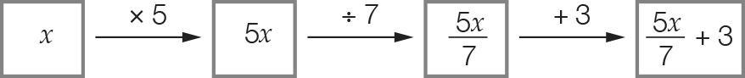

(b) Subtract 9 from an unknown number, d, then divide the result by 5 and finally add 6.

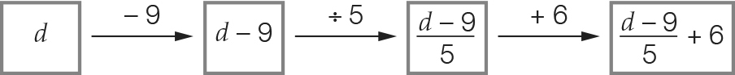

Question 24 4 marks [5.4]

(a)

|  |  |  |  |  |  |
| --- | --- | --- | --- | --- | --- |
| b | 11 | 13 | 2 | 0 | 9 |
| c | 22 | 26 | 4 | 0 | 18 |

(b)

|  |  |  |  |  |  |
| --- | --- | --- | --- | --- | --- |
| p | 1 | 3 | 11 | 15 | 35 |
| q | -7 | -1 | 23 | 35 | 95 |

Short answer total: 52

Extended answer section

Question 25 9 marks [5.8]

(a), (b) (Other answers are possible.), (f)

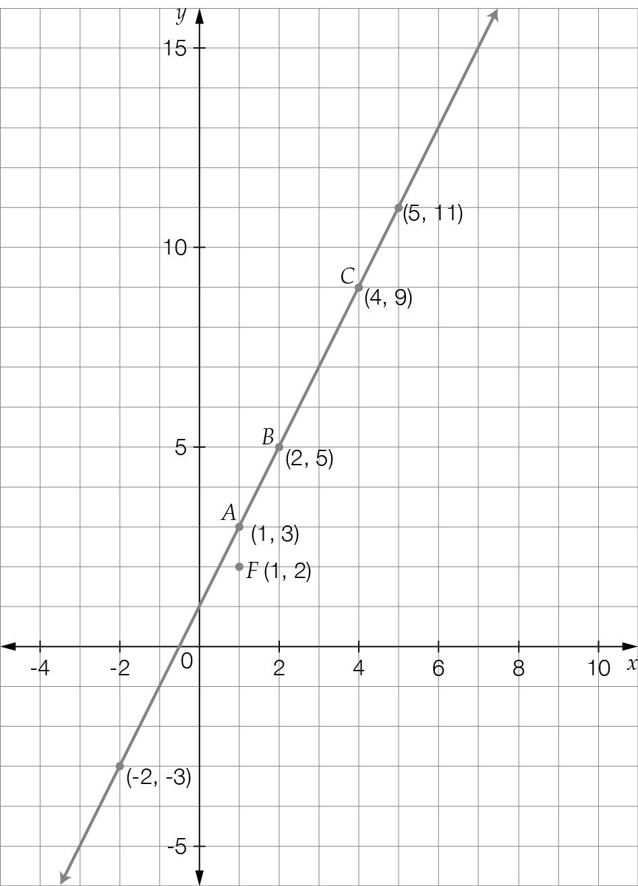

(c)

|  |  |  |  |  |  |
| --- | --- | --- | --- | --- | --- |
| x | -2 | 5 | 1 | 2 | 4 |
| y | -3 | 11 | 3 | 5 | 9 |

(d) y = 2x + 1

(e) Where x = 1:  
y = 2(1) + 1 = 3  
So, the point (1, 2) is not on the line.

Question 26 6 marks [1.6]

(a) Some trial and error may be required to find the answer:  
9 $1 coins and 26 $2 coins  
(The number of $1 coins must be odd to give the odd total of money)

(b) 61 ÷ 3 = , so the children get $20 each

(c) Child 1: 10 × $2 Child 2: 10 × $2 Child 3: 6 × $2 and 8 × $1  
(other answers are possible)

Extended answer total: 15

TOTAL test marks: 79